L.J.Wessel van Leeuwen 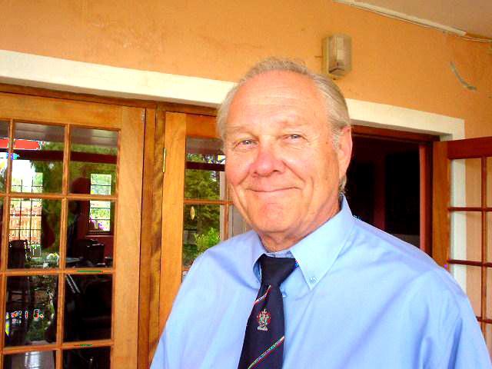
CURRICULUM VITAE
SUMMARY
My experience with translations started in the Netherlands in 1956. I belonged to an International Group. I participated in simultaneous translations at international meetings. (French / Dutch / English / German).

While in Belgium in 1967 I worked for an American Company. I was responsible for Sales and Translation of Catalogues and all communications in the specific languages for the Dutch, Belgian, Luxemburgese and French Markets.

For the past 8 years I have been working with a French-speaking client on a regular basis. I am active as their Management and Business Consultant, advising also on legal issues. I am also involved as their correspondence consultant. I draft all types of correspondence (in French, English and Afrikaans), submit these for approval and then translate in whatever language is necessary. The client signs all correspondence. I translate the answers from whatever language it comes and when called upon, act as interpreter at meetings.

Since then I have continued to do this on an ad hoc basis.

You will no doubt note that having worked in some 16+ different Industries, I can claim to have had an extremely varied business career…(see below). It is said that one learns 80% of a job in the first year. Thereafter? Boredom sets in.

I thank you for considering me and look forward to an enjoyable and fruitful relationship.

And now… who am I:

FIRST NAMES Lodewijk Johannes Wessel
SURNAME van Leeuwen
BIRTH DATE 17th December 1939
ADDRESS 5, Market Street, Greyton, 7233

TELEPHONE +27 28- 254 95 88
CELL +27 82 59 229 88
FAX +27 28 254 95 88
Skype Name cecherwessel
VoipBuster cecherwessel
BIRTH PLACE Democratic Republic of Congo
NATIONALITY Netherlands
STATUS Married, same wife since 1965!
LANGUAGES French, Dutch, German, English, Afrikaans, Swahili and PhD in nonsensology from University of Hard Knocks! Taken me 68 years to get it.)

QUALIFICATIONS

M.B.A. equiv., 1975, Graduate School of Business, University of Stellenbosch
B.& A. equiv., 1973/4, Graduate School of Business, University of Stellenbosch
Sales Management Diploma, Cape technical College,
Institute of Estate Agents, Cape Town
Athenee Royale de Bukavu, (College exam)(Ex Belgian Congo)
M.U.L.O. (A), Culemborg, Netherlands

Worked in: Various Manufacturing / Commerce / Service Industries

 | Industry - Commerce | Knowledge and Experience gained - Comments
1 | Farming (Netherlands, Congo,) | As a worker and leading hand.
2 | Pop & Mom Shop | Attending to client’s needs, stock taking, till reconciliation, merchandising. Also trained business people in these.
3 | Tourism includes Translations | Tourist guide, responsibilities and needs of tourists on a trip, naturally in their own language.
4 | Hotel | Serving at table, housekeeping requirements, and the four critical areas (except the bar, as I am a teetotaller).
5 | Furniture shop | Stocktaking, Merchandising, set up of a Filing system.
6 | Insurance | Short term Insurance. Worked in various departments in Cape Town and Johannesburg
7 | Chemical Industry | Learned manufacturing problems. As technical representative I provided and implemented on the factory floor technical “sticky” solutions to industries such as shoe, building, furniture, packaging, bottling, motor assemblers, canning, clothing, knitting, etc.  My involvement was always with production problems.
8 | Flooring Contractor | Project and Marketing management.
9 | Engineering Plumbing | Sales manager for Benelux and France. Organised and participated in trade fairs, training of sales people, translation of catalogue etc
10 | Wholesaling | Stocktaking, merchandising, resolved delivery problems and set up of an appropriate filing system.
11 | Clothing Industry | As production planner. (Implementing of J.IT. philosophy)
12 | Knitting Industry | Own business and also Production Manager Curtain Manufacturer.
13 | Formal Training | Training & development of Entrepreneurs.
14 | Estate Agent | As agent and also as Owner. Houses, land and farms sales.
15 | Business Broker | As agent and also as Owner
16 | Management Consultant | Various. Also ad Hoc consultancies
17 | Service Bureau | Bookkeeping for land surveyor, restaurateur, Labour Broker
18 | Managing Agent | Commercial and Private Occupancies.

More info?

Click the following…

http://www.proz.com/profile/734738

http://thinkers-think.blogspot.com/

